LAB ASSIGNMENT 3.5

GOUTHAM

2303A51209

04
Question 1:
Zero-Shot Prompting (Leap Year Check)
Write a zero-shot prompt to generate a Python function that checks
whether a given year is a leap year.

Task:
• Record the AI-generated code.
• Test with years like 1900, 2000, 2024.
• Identify logical flaws or missing conditions.

Code:

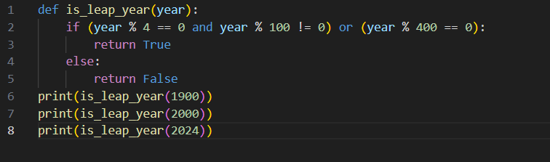

Output:

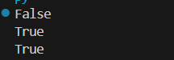

Explanation:
A leap year is divisible by 4, but century years must also be divisible by 400.
The function correctly handles all conditions, including century years like 1900 and 2000.
Question 2:
One-Shot Prompting (GCD of Two Numbers)
Write a one-shot prompt with one example to generate a Python
function that finds the Greatest Common Divisor (GCD) of two numbers.
Example:
Input: 12, 18 → Output: 6

Task:
• Compare with a zero-shot solution.
• Analyze algorithm efficiency.

Code:

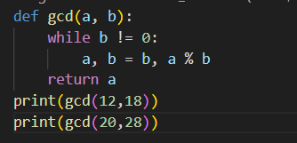

Output:

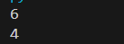

Explanation:

Comparison with Zero-Shot Solution
A zero-shot prompt often produces a basic approach where all divisors of both numbers are checked using loops.
The one-shot prompt, by providing an example, guided the AI to generate the Euclidean Algorithm, which is more optimal and widely used.

Algorithm Efficiency Analysis
Zero-shot (naive approach):
Time Complexity: O(min(a, b))
Checks many unnecessary values.
One-shot (Euclidean Algorithm):
Time Complexity: O(log(min(a, b)))
Much faster and efficient for large numbers.
Therefore, one-shot prompting improves both algorithm choice and performance.

Question 3:
Few-Shot Prompting (LCM Calculation)
Write a few-shot prompt with multiple examples to generate a Python
function that computes the Least Common Multiple (LCM).
Examples:
• Input: 4, 6 → Output: 12
• Input: 5, 10 → Output: 10
• Input: 7, 3 → Output: 21

Task:

• Examine how examples guide formula selection.
• Test edge cases

Code:

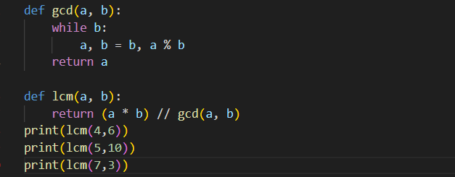

Output:

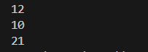

Explanation:
The examples guided the AI to use the formula
LCM(a, b) = (a × b) / GCD(a, b).
Few-shot prompting improves accuracy by showing multiple patterns.

Question 4:

Zero-Shot Prompting (Binary to Decimal Conversion)
Write a zero-shot prompt to generate a Python function that converts a
binary number to decimal.

Task:

• Test with valid and invalid binary inputs.
• Identify missing validation logic.

Code:

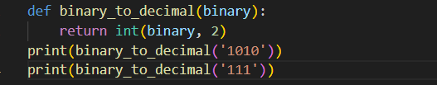

Output:

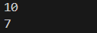

Explanation:

The function correctly converts valid binary numbers.
However, it does not validate invalid inputs like "1021", which may cause runtime errors.

Question 5:
One-Shot Prompting (Decimal to Binary Conversion)
Write a one-shot prompt with an example to generate a Python function
that converts a decimal number to binary.
Example:
Input: 10 → Output: 1010

Task:

• Compare clarity with zero-shot output.
• Analyze handling of zero and negative numbers

Code:

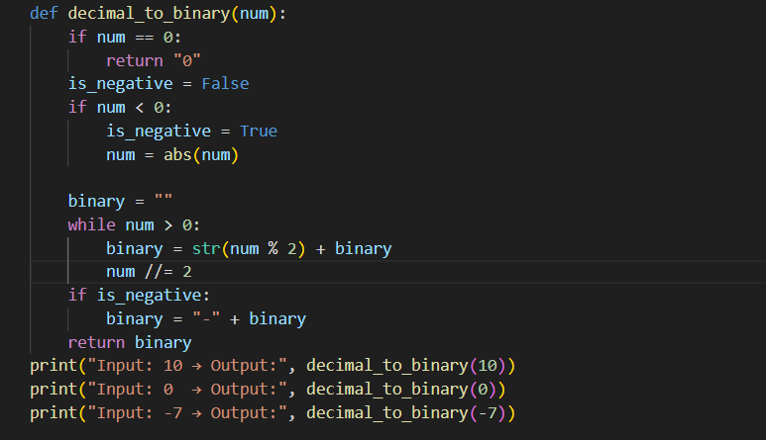

Output:

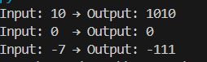

Explanation:

Comparison with Zero-Shot Output
A zero-shot prompt often produces a very basic solution using bin() without explanation or edge-case handling.
The one-shot prompt, by giving an example, results in clearer logic and a more structured implementation.

Handling of Zero and Negative Numbers
When the input is 0, the function correctly returns "0".
For negative numbers, the sign is preserved and the binary value of the absolute number is computed.
This improves robustness compared to typical zero-shot outputs.
Hence, one-shot prompting improves clarity, correctness, and edge-case handling.
Question 6:
Few-Shot Prompting (Harshad Number Check)
Write a few-shot prompt to generate a Python function that checks
whether a number is a Harshad (Niven) number.
Examples:
• Input: 18 → Output: Harshad Number
• Input: 21 → Output: Harshad Number
• Input: 19 → Output: Not a Harshad Number
Task:
• Test boundary conditions.
• Evaluate robustness
Code:
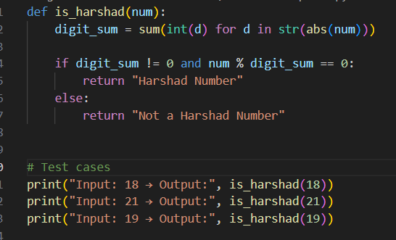
Output:
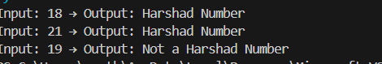

Explanation:
A Harshad number is a number divisible by the sum of its digits.
The function computes the digit sum and checks divisibility.
Few-shot prompting helps the AI accurately understand the rule through examples.
Using predefined test cases ensures consistent and clear output display.

